# Lab #9(B part)

**Task #3**

#include<iostream>

#include<time.h>

using namespace std;

int main()

{

cout << "Enter numbers:";

srand(time(0)); /*we are using*/ /*srand to display random Numbers */

int arr[100];/* Here we are declaring an array of size 100*/

for (int i = 0; i < 100; i++)/* we are using this loop to input values of array */

{

cin >> arr[i];

arr[i] = (rand() % 100) + 1;

}

for (int i = 0; i < 100; i++) /*we are using this loop to display numbers index by index till 100*/

{

cout << arr[i] << " ";

}

system("pause");

return 0;

}

Output

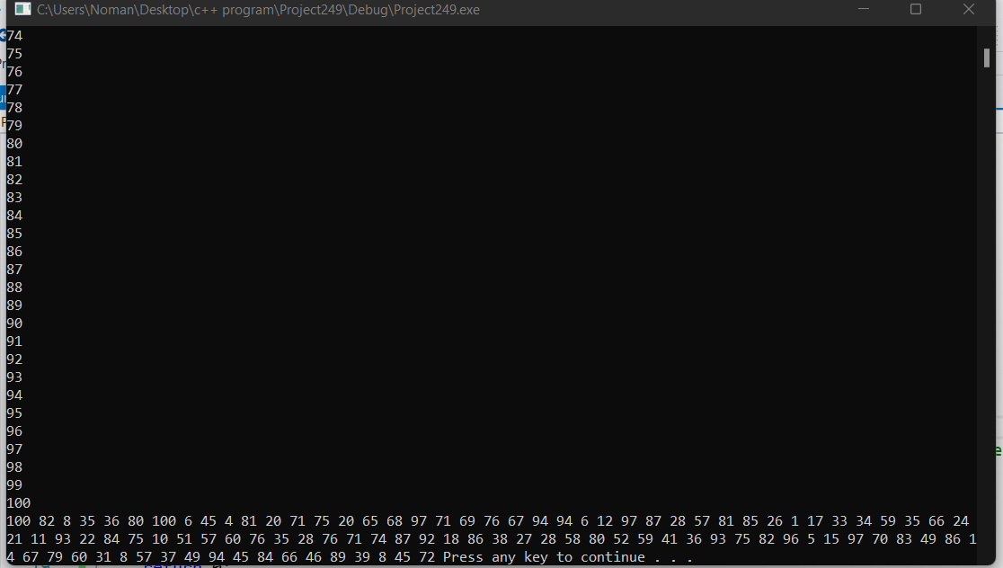

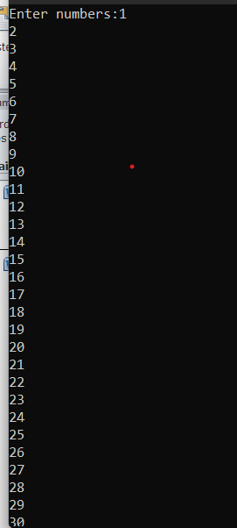

Task #6

A part

#include<iostream>

using namespace std;

int main()

{

cout << "a part ="; int a[5] = { 0,4,3,2,7 }; /*This declaration of array is valid */

cout << "b part ="; int b[10] = { 0,7,3,12 }; /*first four values will be store and other six values will garbage values it is valid for first four values */

cout << "C part ="; int c[7] = { 12,13,,14,16,,8 };/* we can see this part showing errors this is not valid*/

cout << "d part ="; double lengths[] = { 12.7,13.9,18.75,20.78 }; /*first four values will be store others will be Garbage .it is also not valid */

char name[8]= “Samantha ” We can use String as an Array This is not valid

system("pause");

return 0;

}

B part

#include<iostream>

using namespace std;

int main()

{

int list[10] = { 8,9,15,12,80 }; /*This array will store first five values other will be Garbage */

system("pause");

return 0;

}

Task #7

#include<iostream>

using namespace std;

int main()

{

double square,cube; /*Here we are iniliazeing an array of size 50*/

double arr[50] = { 0.0,1.0,2.0,3.0,4.0,5.0,6.0,7.0,8.0,9.0,10.0,11.0,12.0,13.0,14.0,15.0,16.0,17.0,18.0,19.0,20.0,21.0,22.0,23.0,24.0,25.0,26.0,27.0,28.0,29.0,30.0,31.0,32.0,33.0,34.0,35.0,36.0,37.0,38.0,39.0,40.0,41.0,42.0,43.0,44.0,45.0,46.0,47.0,48.0,49.0 };

cout << "The Squares of above index is:" << endl;

for (int i = 0.0; i<=25.0; i++) /*this for loop will display the squares of indexes*/

{

if (i == 10||i==20)/*This is condition for break the line when index will ten*/

cout << endl;

else

cout << i*i << " ";

}

cout << endl;

cout << "The cubes of above index are :" << endl; /*THis for loop will display the cubes of indexes*/

for (int i = 26.0; i <=49.0; i++)

{

if (i == 10 || i == 20) /*This is condition for break the line when index will ten*/

{

cout << endl;

}

else

cout << i*i*i << " ";

}

cout << endl;

system("pause");

return 0;

}

Output

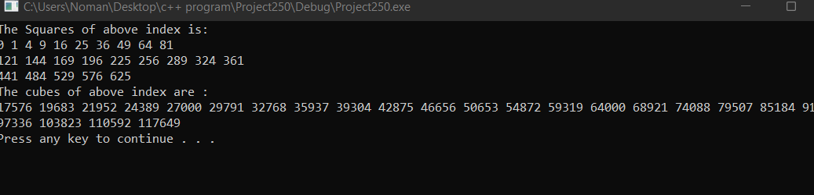

Task #8:

#include<iostream>

using namespace std;

int main()

{

int arr[10]; /*Here we are declaring an aarray of size ten */

int num, count = 0; /*initializeing count*/

cout << "Enter ten numbers in the array :";

for (int i = 0; i < 10; i++) /*This for loop will take ten numbers as input*/

{

cin >> arr[i];

}

cout << "enter the number which you want to search from ten numbers you just given :";

cin >> num;

for (int i = 0; i < 10; i++ ) /*This for Loop will calculate those numbers*/

{

if (arr[i] == num)

count++;

}

cout << "Your search Number exsists " <<" "<<count << " times in the array ";

system("pause");

return 0;

}

Output

